Where no mooring has gone before!

Conditions just under Arctic sea ice during Winter and Spring months are largely a mystery. However, they play a critical role in shaping one of the world’s most highly productive ecosystems during the ice-free Summer months. Scientists at PMEL are developing a new under-ice mooring, capable of collecting oceanographic data at the water-ice boundary during these vital periods. Such data has never been collected before and would give scientists new insights into how this unique ecosystem works.

As the first stage in the development process, two “Exfloat” prototype buoys were deployed off the USCGC Healy during the Arctic Shield Mission.

The buoys will collect data on temperature, depth, and Photosynthetic Active Radiation and transmit the data to shore once free of the ice. The innovative design uses satellite tags (originally designed for [Sea Mammal Research](http://www.smru.st-and.ac.uk/Instrumentation/SRDL/) at the University of St. Andrews), which have been custom programmed to provide a portrait of the environment below.

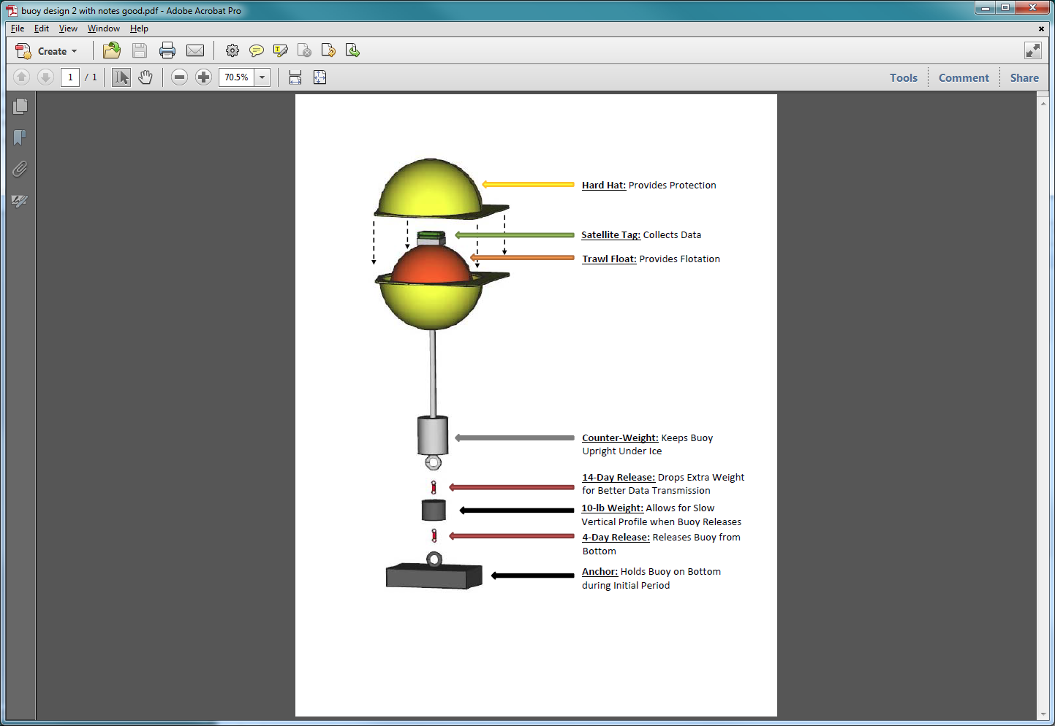Each Exfloat is roughly 4 feet tall and weighs about 50 lbs. They are initially held to the bottom with a metal anchor and use small links called Galvanic Releases to ascend to the surface at the proper time. These releases corrode in salt water at a specific rate, dependent on the water temperature (here about -1°C). The buoys are designed to release from the bottom after 4-days, ascend slowly to the surface, and drop an extra weight after 14-days to lift the unit further out of the water. The diagram here shows the major components of the system.

While the Exfloat is deployed, it logs measurements on the satellite tag powered by a single lithium D-cell battery. After it arrives at the surface and is free of the ice, data is transmitted to the Argos satellite system, which is then downloaded and interpreted by scientists on shore.

Check out an animation depicting the Exfloat prototype operation here! (link or video)